4.4 The Mean Value Theorem

The Mean Value Theorem is one of the most important tools in mathematical analysis. We begin this section by stating a theorem that will be crucial in the proof of the Mean Value Theorem.

Theorem (Rolle’s Theorem): Let f be a function that satisfies the following three hypotheses:
- f is continuous on the closed interval .
- f is differentiable on the open interval .
Then there is a number c in such that .

General Idea:
Geometrically this theorem is saying that there must be a horizontal tangent line to the curve f on the interval when the hypotheses are satisfied. This seems reasonable if we draw the following pictures.
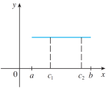
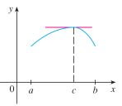
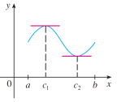

In the left most picture we see there are infinitely many points in the interval that show the theorem to be true. In the middle picture we see that there is exactly one point which shows the theorem to be true.
In the right most picture there are exactly two points which show the theorem to be true.
We now present a rigorous proof of Rolle’s Theorem.

Proof:

We break the proof into three cases.

Case 1: , a constant.
In this case . Therefore, we can have c be any number in the interval .

Case 2: for some x in .


By the Extreme Value Theorem (we can apply this due to hypothesis 1), f has a maximum value at some point in . Since this must occur for some value c in the interval . Therefore, f has a local maximum at c and, by hypothesis 2, f is differentiable at c, so by Fermat’s theorem.
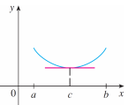

Case 3: for some x in .
This case is similar to case 2.
By the Extreme Value Theorem (we can apply this due to hypothesis 1), f has a minimum value at some point in . Since this must occur for some value c in the interval . Therefore, f has a local minimum at c and, by hypothesis 2, f is differentiable at c, so by Fermat’s theorem.

Question: What does Rolle’s Theorem tell us about a ball that is thrown upward from ground level and comes back to the ground?

Example 1: Consider the function on .
- Verify that the hypothesis of Rolle’s theorem are satisfied on the given interval.

Hypotheses
- f is continuous on because f is a polynomial.
- f is differentiable on because is a polynomial.
- so clearly .

- Find all values of c in that interval that satisfy the conclusion of the theorem:

Since the hypotheses are satisfied we know by Rolle’s theorem there is at least one point c in such that .

We calculate that .
So, .
Thus, the only value of c which satisfies the conclusion of the theorem is 2.

Example 2 (if time permits): Use Rolle’s Theorem to prove that the equation has exactly on real solution.

Show there is at least one real root
Let . We know that f is a continuous function because it is a polynomial.
We can see that:
Therefore by the IVT there exists a number c in the interval such that .
Therefore we have shown that has at least one real root and thus there is at least one real number solution to the equation .

Show there cannot be two real roots
Assume that there are two real roots, say (so we are calling c & d roots).
Since f is a polynomial, we know that is continuous on the interval and differentiable on the interval , regardless of what the values of c & d are. Therefore we have satisfied the conditions for Rolle’s theorem so we can then say, there is a number e in such that . We note that .
However, when we look to find when we can see that this is not possible since for all x. This is a contradiction!

Therefore our initial assumption must be false. There cannot be two real roots. So we have shown that the equation has exactly one real solution.

Theorem (The Mean Value Theorem): Let f be a function that satisfies the following hypotheses:
- f is continuous on the closed interval .
- f is differentiable on the open interval .
Then there is a number c in such that .

General Idea:
Geometrically this means that the slope of the tangent line at some point c is the same as the slope of the secant line that connects the points & .
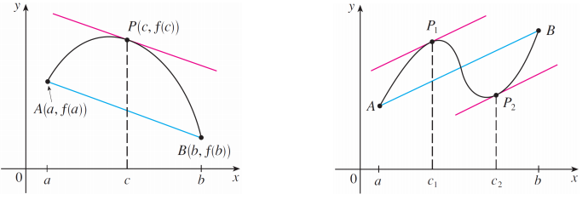
Notice that in the pictures the red line(s) and the blue line have the same slope. The slope of the red line is $tice that in the pictures the red line and the blue line have the same slope. The slope of the red line is$and the slope of the blue line is .

Proof:
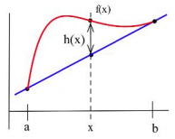
We begin by constructing an equation for the secant line AB.

Let h be a function defined as the difference between the function f and the secant line AB.

We wish to apply Rolle’s theorem to the function h so we must first show that h satisfies the three hypotheses.
- The function h is continuous on because it is the sum of a linear function and f which is given as continuous on the interval .
- The function h is differentiable on because both f and the linear function y are differentiable.
- We note that:
&
Therefore we have that .

So the function h satisfies the conditions of Rolle’s theorem and therefore, there is a number c in such that .
We can compute that . Since , we have that which proves the desired result.

Example 3: Verify that the function satisfies the conditions of the Mean Value Theorem on the interval . Then find all numbers c that satisfy the conclusion of the Mean Value Theorem.

- f is continuous on the interval because f is a polynomial.
- f is differentiable on the interval because f is a polynomial.
Therefore by the MVT, there is a number c in such that . We note that . So, we solve . So the only number in which satisfies the conclusion is .
Question: If for all x in , what can we say about the function f ?

If we think about this geometrically, we would guess that f is constant.

To prove this, suppose that m and k are unequal numbers in . By the MVT there is a c between m and k such that:
Thus, f has the same value at any two numbers in which means f is constant on .

Theorem: If for all x in , then f is constant on .

Corollary: If for all x in, then there is a constant C such that for every x in .

Example 4: Use the most recent theorem to prove the most recent corollary.
(Hint: Consider the function )

Suppose that for all x in . Consider .
We note that .
So, by the most recent theorem there is a constant C such that: for every x in .

Note: The above corollary is of fundamental importance in the study of differential equations and integral calculus.

